News for medplants4vet.eu

1. Title

* Maximum 60 characters, including spaces
* Clear and understandable
* The title should refer directly to the current event or topic in order to arouse interest.
* The title should provide enough information, but not give everything away so that the reader wants to open the article.

**Example:** Successful Conclusion of the First MP4V Training School

1. Lead

The lead is the first paragraph of a news article and should summarize the most important information in a compact form.

* Maximum 300 characters, including spaces (2-3 sentences)
* A good lead answers the most important questions directly so that the reader quickly understands what it is about.
* The lead should concisely convey the most important message of the article - without unnecessary details or background information.

**Example:** From February 12 to 14, the first MP4V Training School, "Herb Power for Animal Health: From Tradition to Legislation," took place in Warsaw, Poland—and it was a resounding success! Participants from across Europe seized the opportunity to dive deep into the fascinating field of herbal veterinary medicinal products.

1. Body text

In the body text of a news article, it is important to present the information in a logical and understandable way.

* • Maximum 1200 characters, including spaces
* Use clear, understandable language:
  + No complicated or convoluted sentences.
  + Explain technical terms if necessary.
  + Prefer direct, active formulations.

**Example:**

The three-day program was packed with engaging lectures and discussions covering a wide range of topics. In addition to exploring the historical and practical applications of herbal remedies, attendees examined key aspects such as legislation, registration, and risk assessment, as well as strategies for sustainable production and use.

A particular highlight was the hands-on workshop on quality assessment of raw plant materials, where participants got first-hand experience with pharmacopeial evaluation processes.

Beyond the educational content, the training school fostered an exceptional environment for networking and collaboration. Participants connected with like-minded peers, exchanged insights, and laid the foundation for a dynamic scientific community in the field of veterinary herbal medicine.

With this successful launch, MP4V has taken an important step towards advancing research and application in herbal veterinary medicine. We look forward to our next online learning modules and training courses!

1. Additional material

Please send at least one picture (photo, illustration, diagram).

* • Pictures in .png format if possible
* • Please provide the name and institution of the photographer and make sure, we are allowed to use the pictures.
* • Please provide the references for illustrations, diagrams or other material.
* • Write a legend for each picture.

Example:

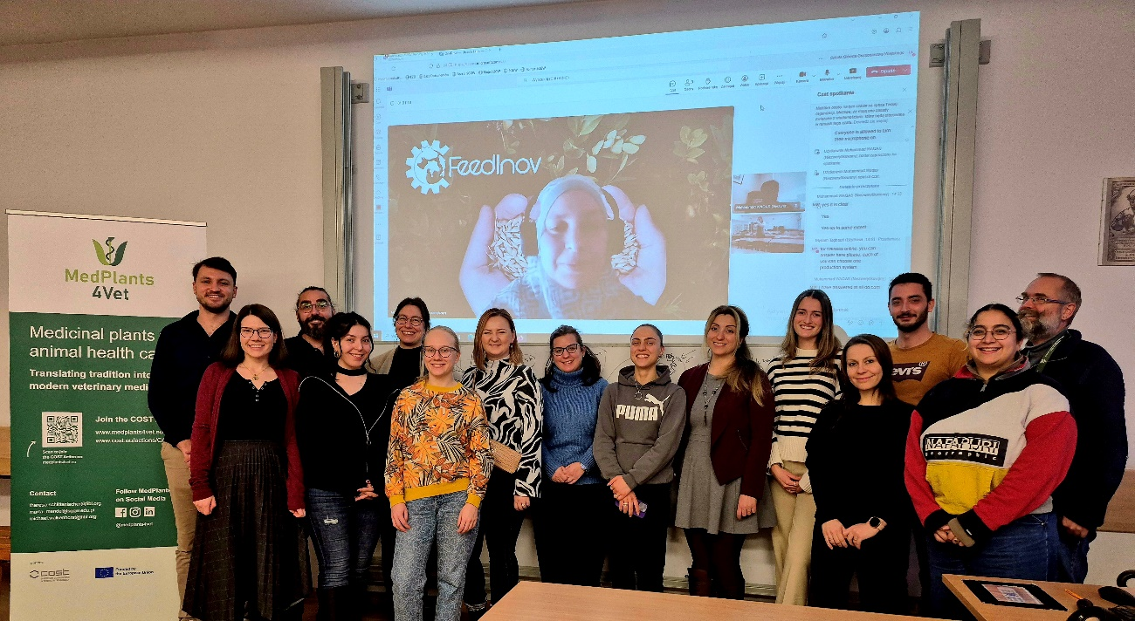

Young researchers from across Europe enjoyed three days of networking, lectures and discussions at the University of Warsaw. (Photo: Urszula Latek, University of Warsaw)