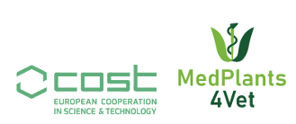
COST Action CA22109
https://www.medplants4vet.eu

STSM Detailed Budget Form

Requested budget (Euro) with clear justifications, including the mode of transport
Please list other funding you have applied for. When making travel arrangements, MedPlant4Vet encourages candidates to choose, when possible, a sustainable mode of transport.
The calculation of the financial contribution for each STSM will be up to a maximum of the daily allowance per day in the specific country and travel costs, up to a maximum of EUR 4000 in total.
We recommend that the requested grant does not exceed EUR 1000 for 1 week and EUR 2000 for one month, otherwise it must be justified.

Requested budget details

Amount | Justification (food, transport, …)
TOTAL AMOUNT | €

Mode of transport:

Other fundings

Name | Granted? | Amount | Destination and period

